What will we be learning?  Paper 1  Section 2 - Physical Training | Why this? Why now?  GCSE PHYSICAL EDUCATION  SECTION 2 (Paper 1)  This unit is taught in Year 10 but will also link as synoptic topic to paper 2 in Year 11.  There is also a practical element to this unit that will link into the AEP written coursework.  You will develop your knowledge and understanding of the components of fitness required for physical activities and sports and how each can be measured. You will also be able to apply knowledge of training principles to personal exercise/training programmes to improve fitness, along with the knowledge of how to optimise training and helping to prevent injury. | Key Words:  Cardiovascular endurance  Stamina  Speed  Strength  Power  Agility  Balance  Flexibility  Coordination  Reaction time  Normative data  Vo2 Max  Mitochondria  Myoglobin  Fast/ Slow Twitch Muscle Fibres  Anaerobic  Aerobic  Cooper 12 minute run  Multistage fitness test  Ruler drop test  Illinois Agility run  Stork stand test  Vertical/ Standing Broad jump test  30m Sprint  Sit up/ press up test  Grip dynamometer test/ 1 rep max  Stretching  Warm up/ cool down  SPOR  FITT  Training  Hazards  PPE
What will we learn?
2.1. Components of Fitness
The components of fitness
Definitions of each component of fitness
Knowledge of suitable tests for each component of fitness
Collection and use of data relating to the components of fitness
Application of practical examples for each of the components of fitness

2.2. Applying the principles of training
The principles of training - SPOR
Definitions of each of the principles of training
Application of these principles to practical examples (training programmes)
Optimising training - FITT principle
Different types of training
Key components of a warm up and cool down
Physical benefits of a warm up and cool down
2.3 Preventing injury in Physical
Prevention of injury
Hazards in various physical activity and sports settings

What opportunities are there for wider study?
Sixth form studies
- Cam Tech Sport
- A level PE
Careers/degree courses
- Sports science
- Physiotherapy
- PE teacher
How will I be assessed?
- Paper 1 (30%) 60 marks – 1 hour
- AEP Written Coursework

2.1 COMPONENTS OF FITNESS

Components of fitness
- Know the definition and be able to apply practical examples of:
  - Cardiovascular endurance/stamina – Cooper 12-minute run/ multistage fitness test
  - Muscular endurance – Press up/ sit up test
  - Speed – 30m sprint test
  - Strength – Grip strength dynamometer/ 1 rep maximum
  - Power – Standing broad jump/ vertical jump test
  - Agility – Illinois agility test
  - Balance – Stork stand test
  - Flexibility – Sit and reach test
  - Coordination – Wall throw test
  - Reaction time – Ruler drop test
2.2 APPLYING THE PRINCIPLES OF TRAINING  Principles of training  - Know the following definitions of principles of training and be able to apply them to personal exercise/ training programmes:  - Specificity  - Overload  - Progression  - Reversibility  Optimising training  - Know the definition of the elements of FITT (Frequency, Intensity, Time, Type) and be able to apply these to person exercise/ training programmes.  - Know the different types of training, definitions, and examples of – Continuous, fartlek, interval, circuit, weight, plyometrics, HITT  - Understand the key components of a warm-up and be able to apply examples: pulse raising, mobility, stretching, dynamic movements, skill rehearsal.  - Understand the key components of a cool down and be able to apply examples: low intensity exercise, stretching.  - Know the physical benefits of a warm-up, including effects on: warming up muscles/preparing the body for physical activity, body temperature, heart rate, flexibility of muscles and joints, pliability of ligaments and tendons, blood flow and oxygen to muscles, the speed of muscle contraction.  - Know the physical benefits of a cool down, including: helps the body’s transition back to a resting state, gradually lowers heart rate, gradually lowers temperature, circulates blood and oxygen, gradually reduces breathing rate, increases removal of waste products such as lactic acid, reduces the risk of muscle soreness and stiffness, aids recovery by stretching muscles. | 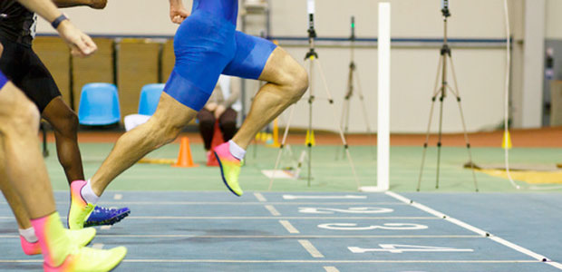
2.3 PREVENTING INJURY IN PHYSCIAL ACTIVITY AND TRAINING  Prevention of injury  - Understand how the risk of injury in physical activity and sport can be minimised and be able to apply examples, including: personal protective equipment, correct clothing/footwear, appropriate level of competition, lifting and carrying equipment safely, use of warm up and cool down.  - Know potential hazards in a range of physical activity and sport settings and be able to apply examples, including: sports hall, fitness centre, playing field, artificial outdoor areas, swimming pool. | 